LPA Cheat Sheet

**How to design and send an EDM**

Logging into the LPA website backend

Each user will have a unique log in to access the new LPA website backend. This is where all the edits to the website happen and where resources are uploaded and stored.

To access the backend click - <https://liveperformance.com.au/wp-admin>

* **Username:** LPAstaff
* **Password:** Welcome2LPA!
* **Email:** noreply@liveperformance.com.au

Backend Basics

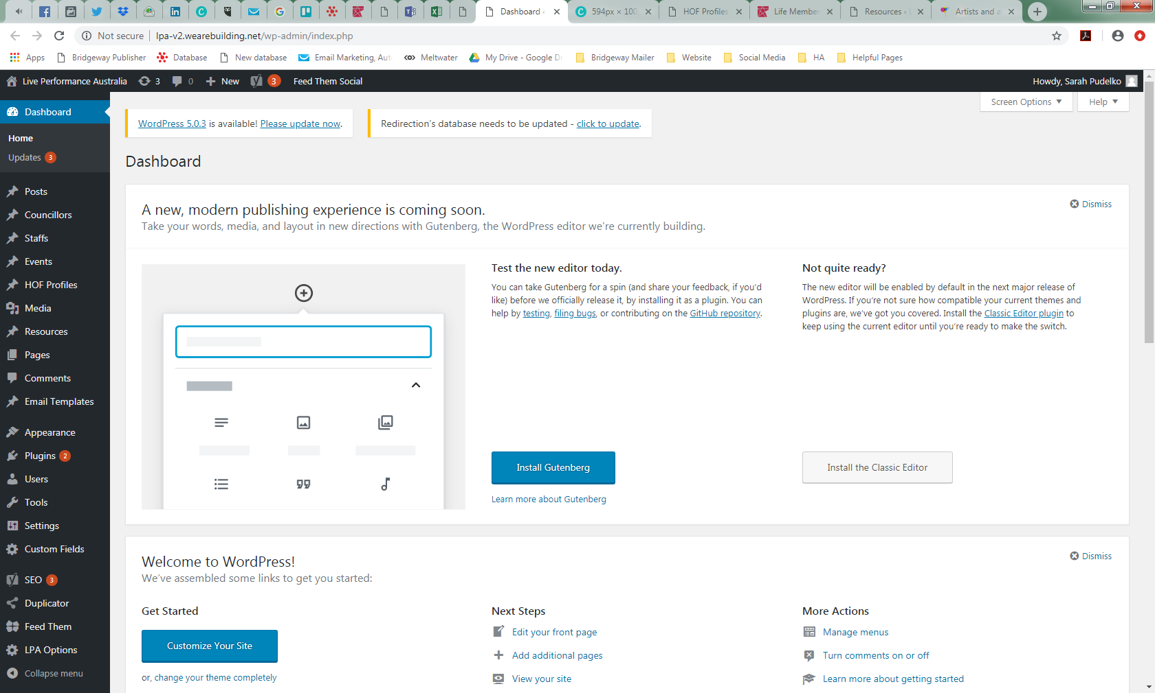

The website is designed to be user-friendly and intuitive, so the method of editing sections will be fairly similar across the website. The main thing to remember is to **ALWAYS** preview your changes before ‘going live’ to avoid errors and click ‘update’ when changes are made so that they appear on the website. The website is meant to be low maintenance with only a few sections to be updated.

What can you update?

The website is only able to be updated by the Marketing Coordinator. Please send through your proposed edits via email and organise a meeting to discuss. Depending on the edits (more than just a spelling or grammatical edit) they will need to be preapproved by the Chief Executive and Director, Marketing.

The website content has been written with a professional copywriter so avoid making changes which change the tone and writing style as it will be inconsistent with the rest of the website.

When editing the website, you need to first find the appropriate section in the backend. Most things will be in ‘Pages’ but when updating sections to do with people they will either be in ‘Staffs’, ‘Councillors’ or via the database (more on this later).

The left side bar has the following options and functions that need maintaining, all other sections are **NOT** to be touched as they affect the look and functionality of the website.

Councillors

This section is where you update the President, Vice-Presidents, EC and Observers so that they feature on the front end / user view which can be seen [here.](https://liveperformance.com.au/executive-council/)

Each Councillor has a profile like the one shown below. Hovering over the profile will give you options to edit, delete and clone.

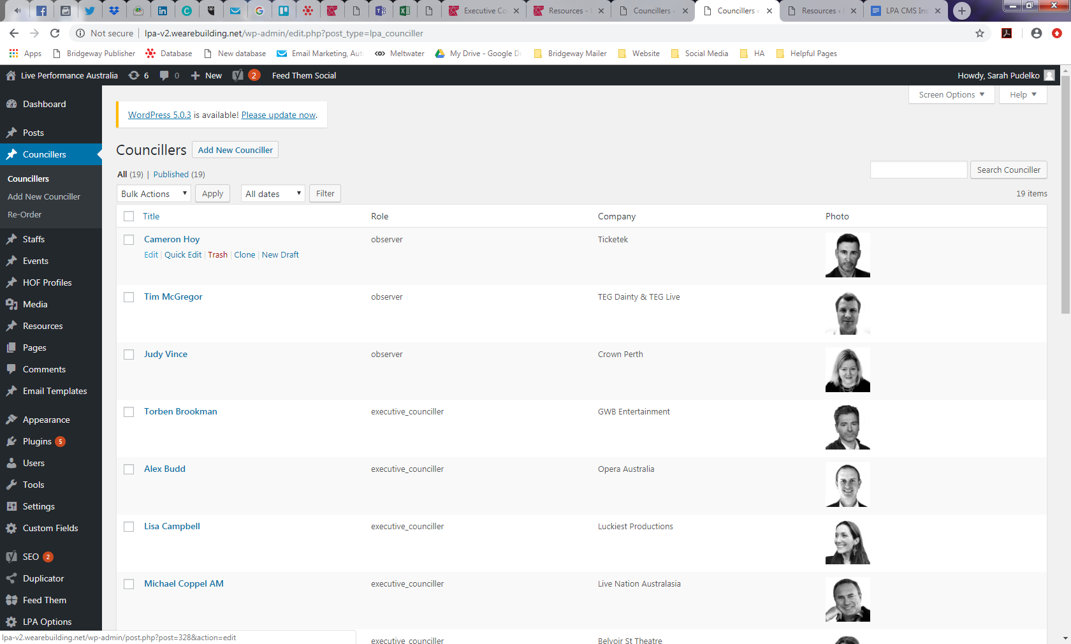

This page should be updated each time there is a change in the EC members. Please get the Operations Manager to check that everyone is correctly represented prior to publishing.

You will need the following:

1. Full name (including honorifics)
2. Role: President, Vice-President, EC or Observer
3. Company they work for
4. Their headshot
5. Current headshots are saved here: I:\Meetings and Committees\Executive Council\Administration\Headshots
6. To have a headshot edited please contact Sean our freelance graphic designer on [sean@leonardbroscreative.com](mailto:sean@leonardbroscreative.com) or 0438 372 800

Staffs

This section is where you update LPA staff. The front end / user view can be seen [here](https://liveperformance.com.au/staff/). Staff should be updated each time there is an employee change e.g. Helpmann Awards Administrator hired.

The steps are the same as above, each person has a profile which can be edited. It looks like this:

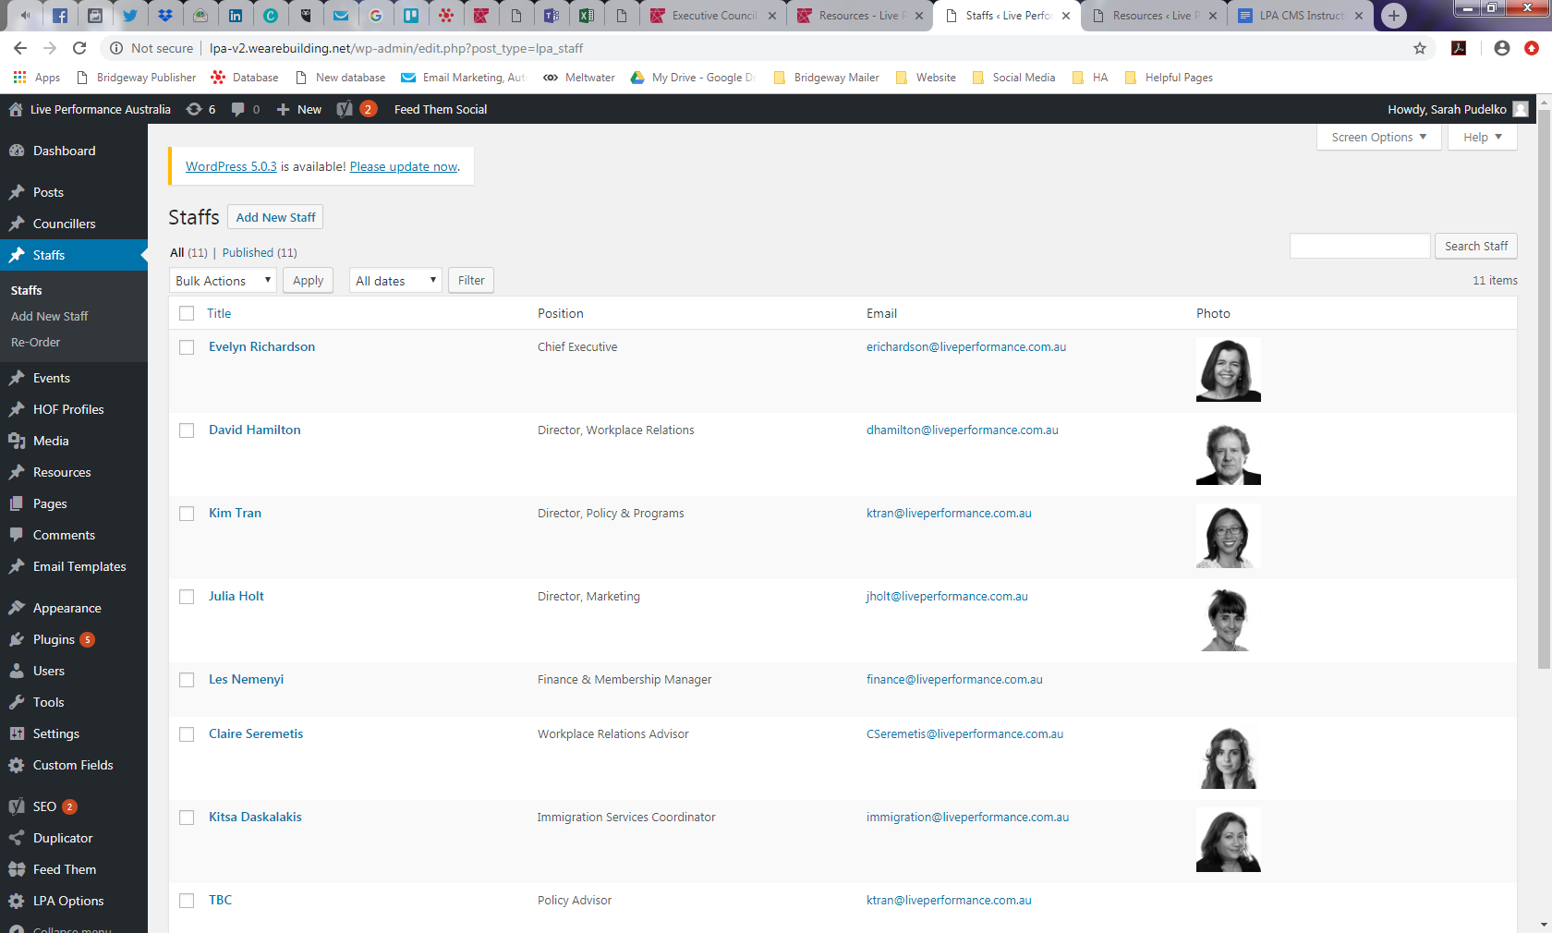

You will need the following:

1. Full name (including honorifics)
2. Role
3. Their email
4. Their headshot
5. Current headshots are saved here: I:\LPA Communications\LPA Staff Headshots
6. To have a headshot edited please contact Sean our freelance graphic designer on [sean@leonardbroscreative.com](mailto:sean@leonardbroscreative.com) or 0438 372 800

Events

This is the section where you add in LPA event such as Member Briefings, Helpmann Awards Dates and Member Training. Please don’t add things in here such as Post Helpmann Awards Lunch and Christmas Parties which are Member events.

To add a new event:

1. 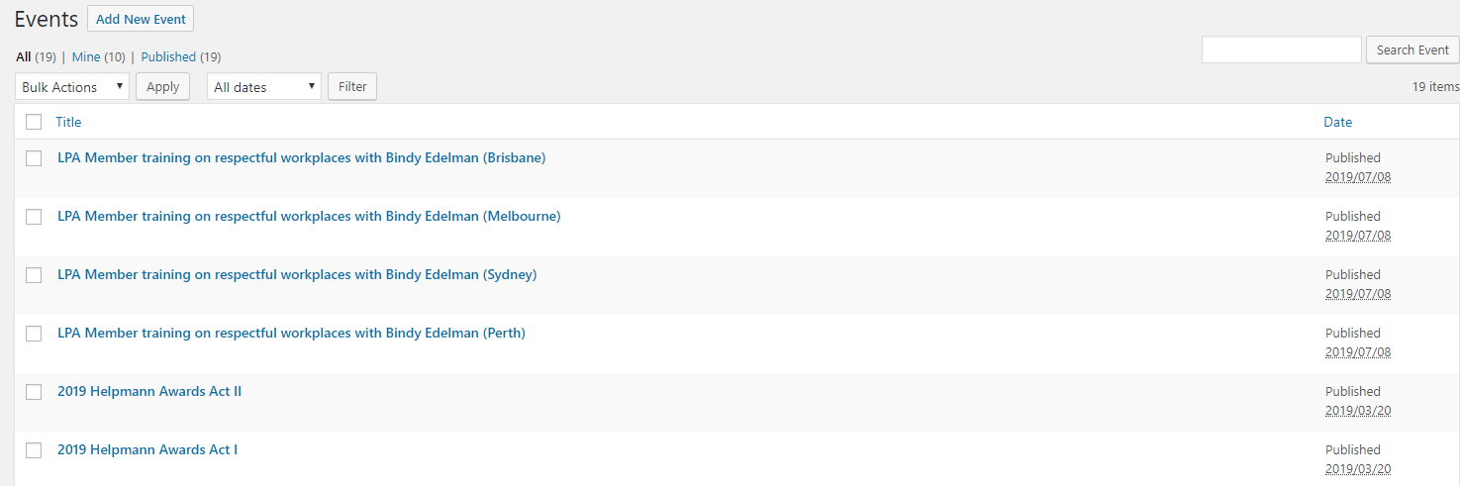Click on ‘Add New Event’
2. Fill in the details required:
   1. Add in the title
   2. Date of the event
   3. Tick ‘mark this as key date’ so it appears on the front end / user view
   4. Fill in an excerpt which is a short summary of the event
   5. 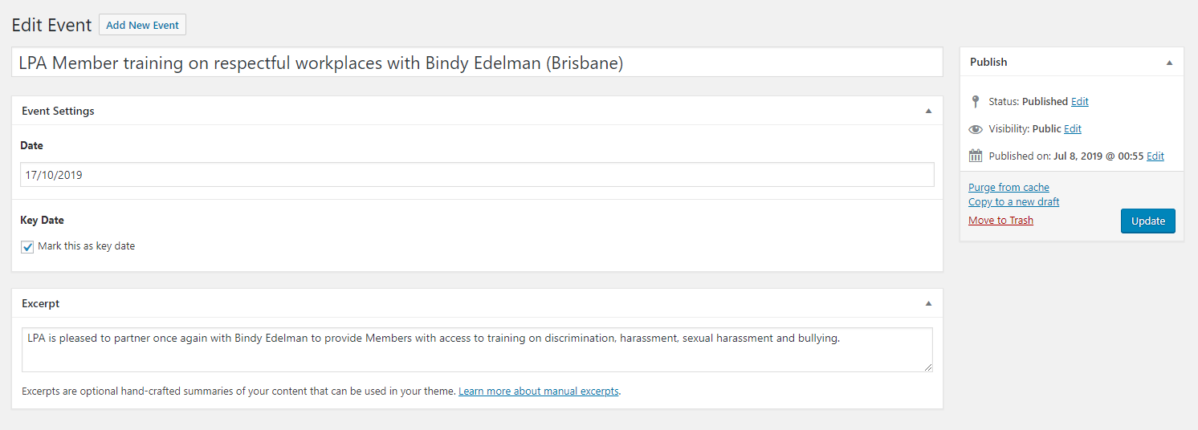Click publish

More functions:

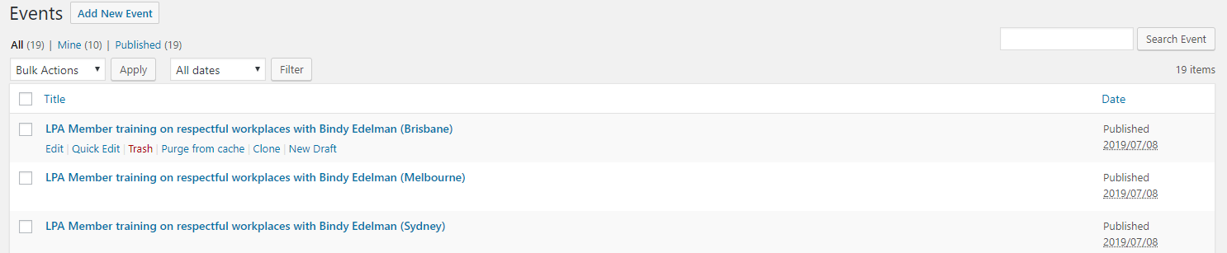Hover over the event title in the event listing (such as below) to get more functions

1. Edit and Quick Edit: Gives you the option to edit an event if any details have changed since publishing
2. Trash: Please don’t use this as past events will drop off
3. Purge from Cache: ignore
4. Clone: Gives you the option to clone an existing event and update the details for a new event
   1. This can be used when there are multiple industry briefings.
5. New Draft: ignore

HOF Profiles

This is the section for the Hall of Fame profiles. The front end / user view can be seen [here](https://liveperformance.com.au/hall-of-fame/). These are up to date as of August 2019 and will need to be updated yearly post Helpmann Awards (JC Williamson and Sue Nattrass Award recipients will be added here).

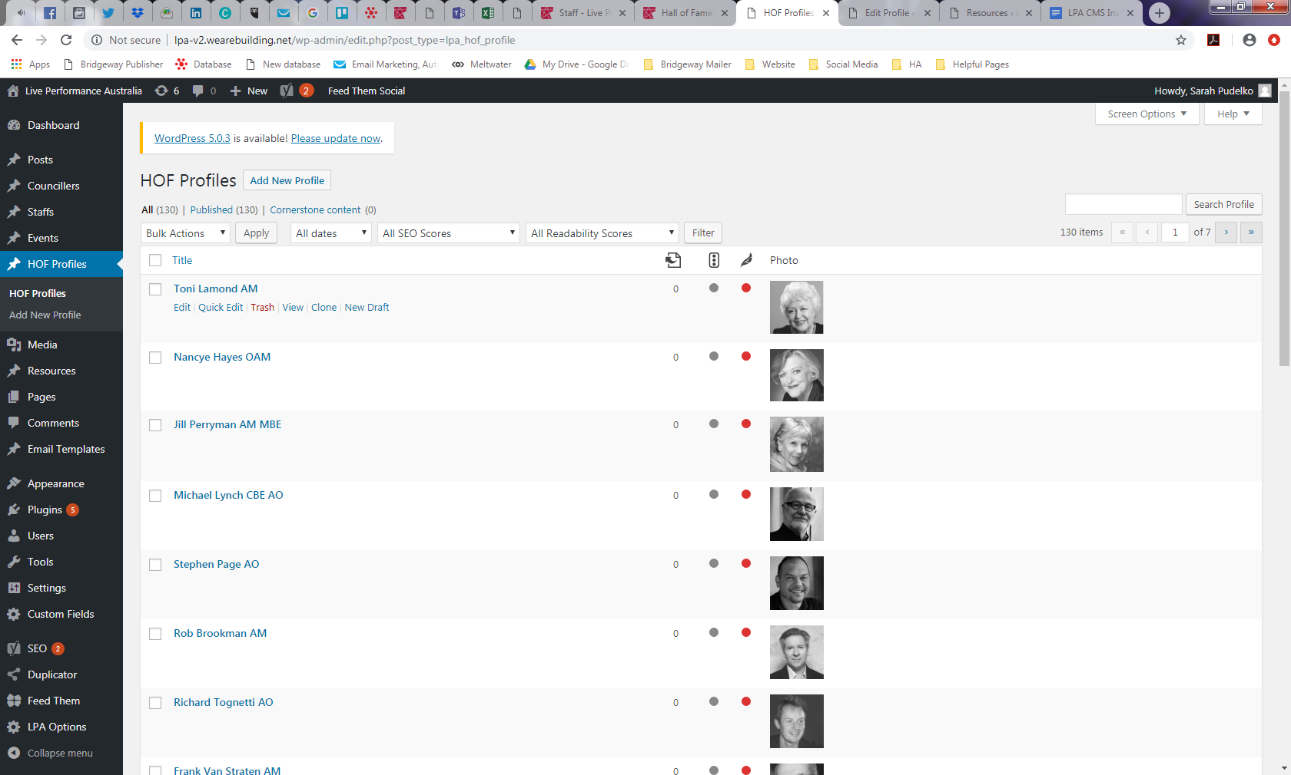As with the ‘Councillors’ and ‘Staff’ sections each person has an editable profile which looks like this:

You will need the following:

1. Full name (including honorifics)
2. Decades (refers to the decades that they are/were alive)
3. Short description (like a blurb)
4. Long description (biography)
5. Any related links or references (may not have these for each person, this is okay to leave blank)
6. Featured image (please use a black and white image – this can be done inhouse on Canva, the filter is ‘greyscale’)

Remember to click ‘publish’ for their profile to appear live on the website.

**Tip:** To make sure you are following the correct formatting open another HOF profile and copy how it was done.

Media

The main purpose of ‘Media’ is to store all content including headshots, resource document files, HOF recipient photos and any other graphics relevant to the website.

Media replaces Bridgeway Publisher for creating links to documents. The main difference between Bridgeway Publisher and the Media section is that documents don’t have to be in a PDF format. We can create links to word documents, photos, powerpoints etc.

To upload a document and generate a link:

1. Drag and drop the file into the library (list of documents)
2. Click on the uploaded document
3. You will find the URL on the right as the first line of boxed content

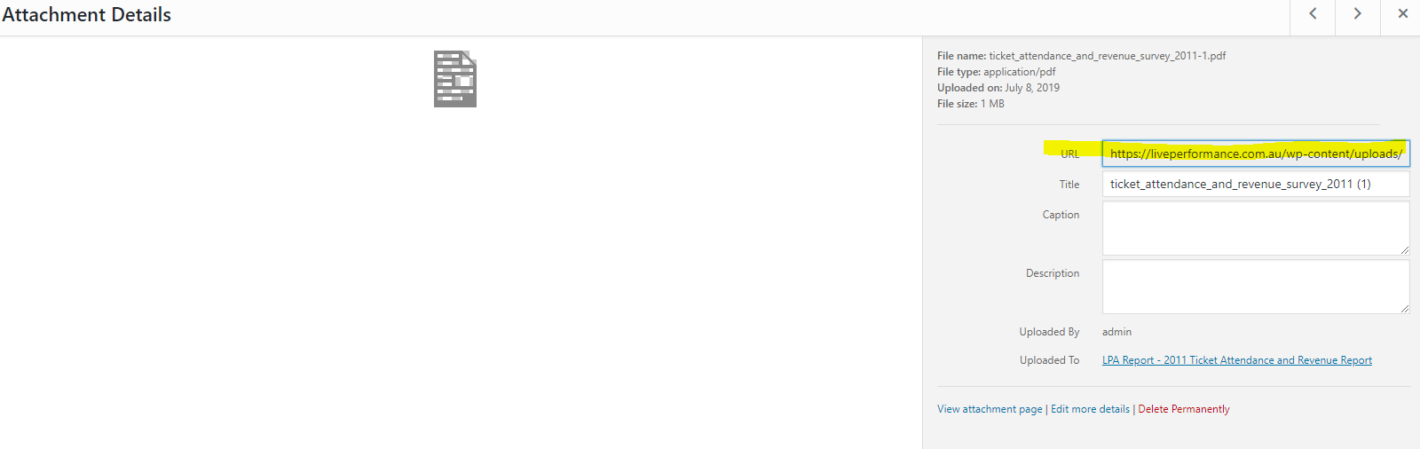

Resources

Think of the resources section like a library. All external LPA documents available to Members and the general public are stored here. This replaces the old ‘Members Area’.

No documents are to be uploaded to ‘Pages’, upload these to the ‘Resources’ section. A separate document detailing how to add and edit resources has been provided to you.

Click [here](https://liveperformance.com.au/resource) to see the front end / public view of the resources section.

Pages

This is where the content on all the pages is edited. Please be very careful with changes especially in pages such as ‘[About Us](https://liveperformance.com.au/about/)’ where there are multiple components, buttons and links to the website navigation as even minor edits can change website features. **ALWAYS** preview your changes and once you are happy with them then click ‘update’.

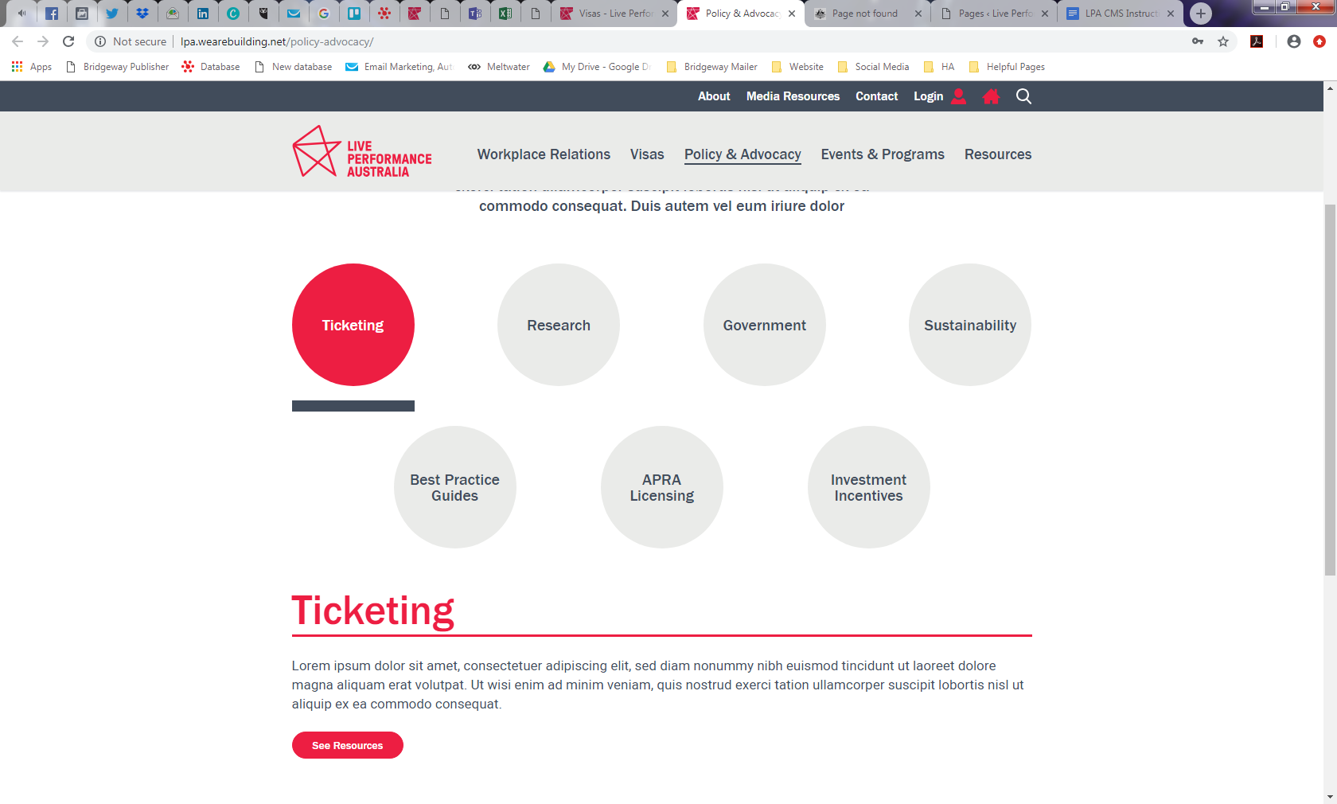Content is limited to a blurb with more information linked to resource documents as per the example below:

Hovering over the page titles will provide you with editing options as per the other website components. It looks like this:

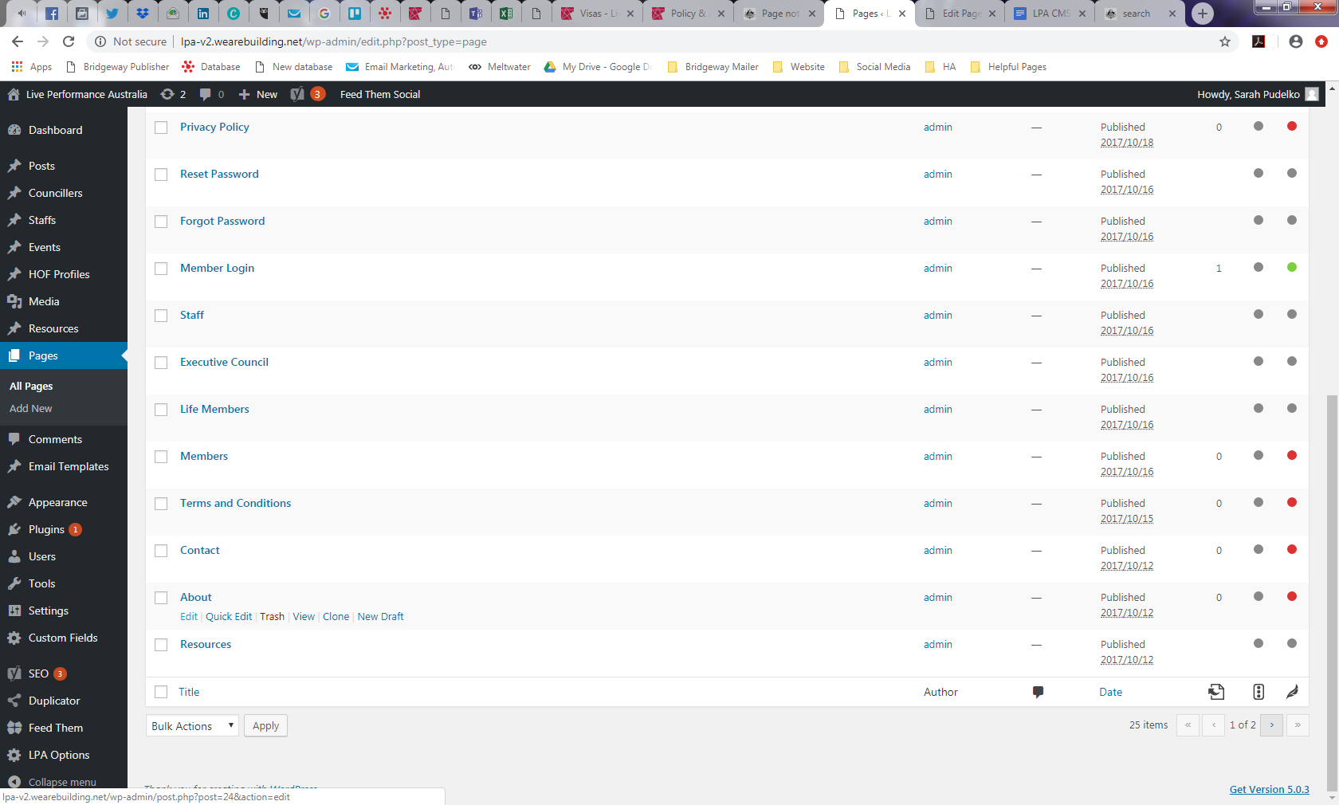

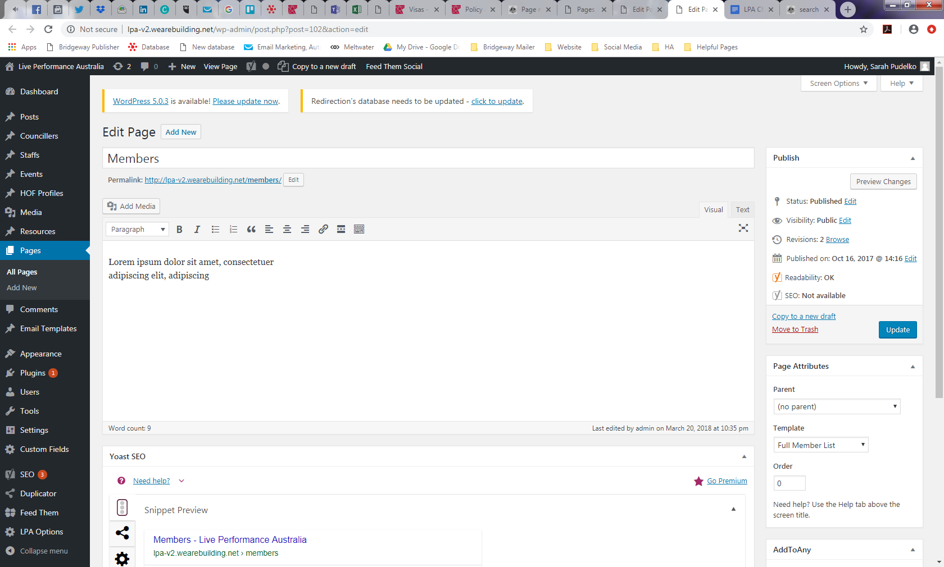Once in the page editing function you will find the building blocks of the page contents. Most pages will only have a short blurb and editing is straightforward. Type your content here

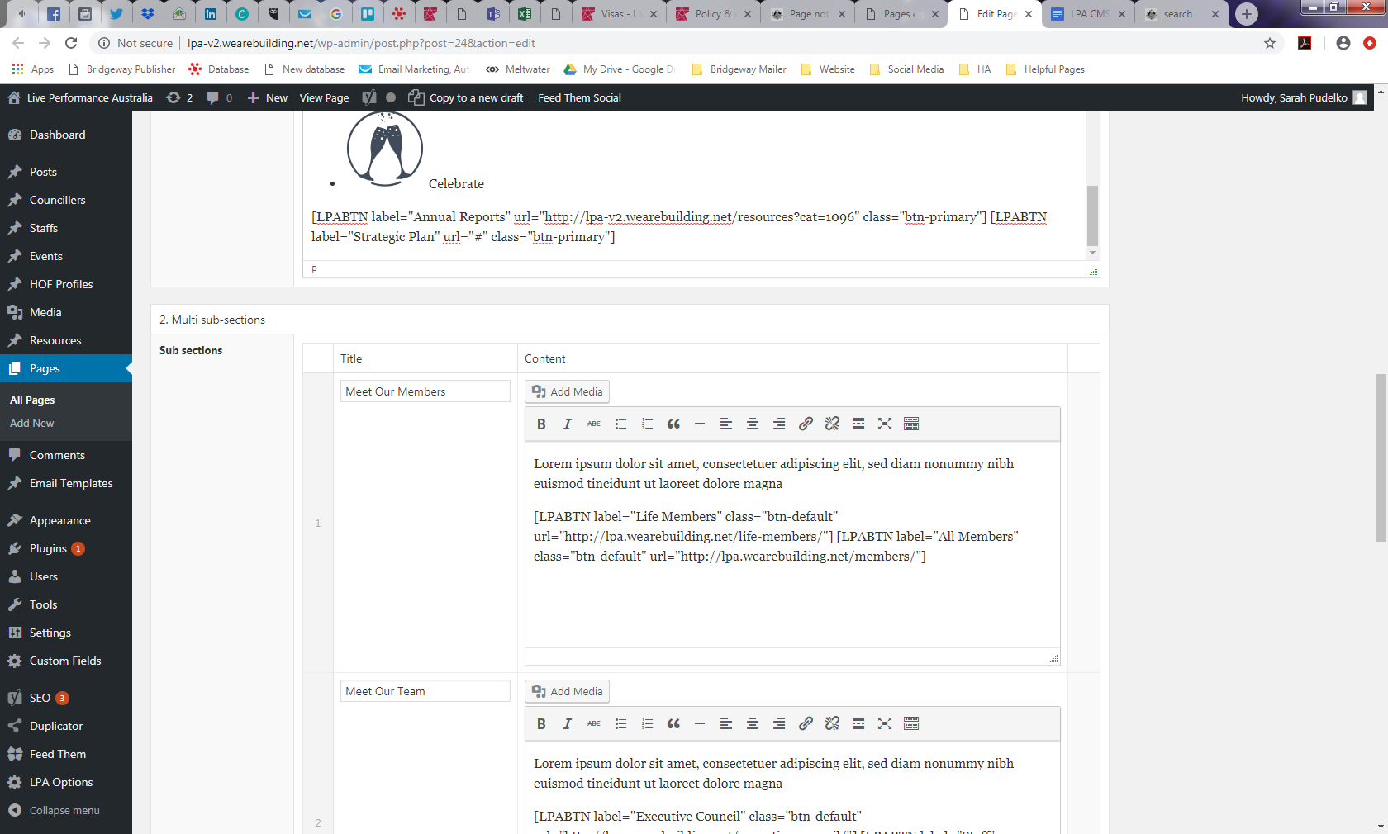In the more advanced pages such as the previously mentioned ‘About Us’ the method of editing remains the same but there are more components.

Type your content here

Ensure you are updating the correct box and don’t remove button codes such as this:

[LPABTN label="Life Members" class="btn-default" url="<https://liveperformance.com.au/life-members/>"]

This is what you want the button to display.

This is the link you want it to go to.

Red Button Shortcode:   
[LPABTN label="Annual Reports" url="http://liveperformance.com.au/resources/?type=120" class="btn-primary"]

Grey Button Shortcode:   
[LPABTN label="Life Members" class="btn-default" url=" liveperformance.com.au /life-members/"]

Users

This section is for adding, editing, deleting and allocating roles to users who can access the LPA website backend (LPA staff and developers).

Administrator access should only be given to the main person maintaining the website, everyone else who can edit should have author access. A breakdown of permissions (user access levels) can be found [here](https://www.wpbeginner.com/beginners-guide/wordpress-user-roles-and-permissions/).

Life Members

This section is up to date as of August 2019. To make edits in this section you need to be logged into the database.

Search the person’s name in the ‘Organisations’ section of the database and click into their card file as shown below.

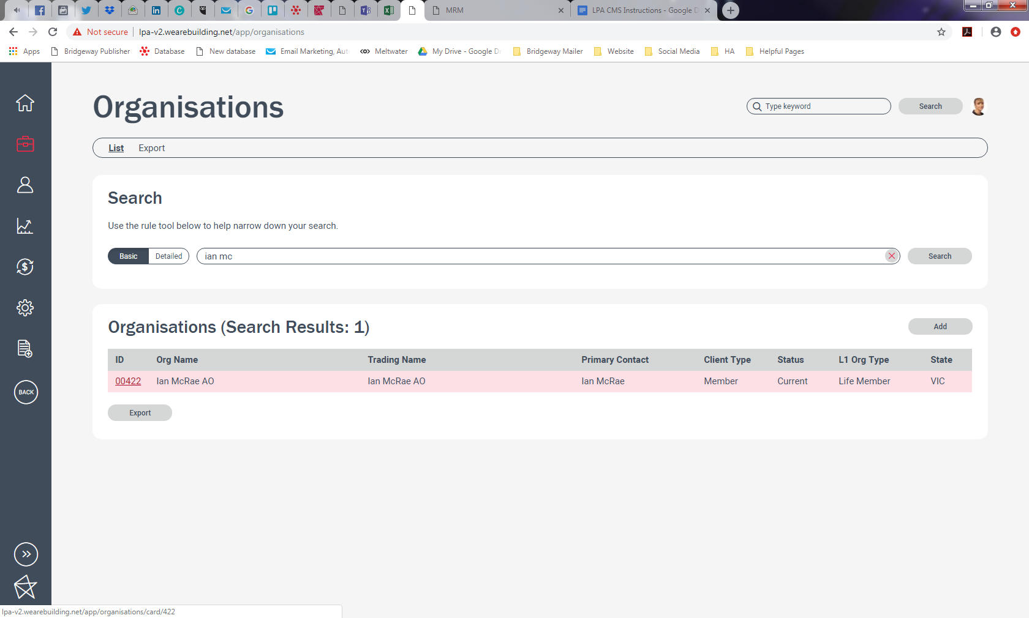

You will need the following:

1. Full name (including honorifics)
2. Their headshot
3. Current headshots are saved here: ..\..\LPA Communications\Life Members\_LIFE MEMBER IMAGES
4. To have a headshot edited please contact Sean our freelance graphic designer on [sean@leonardbroscreative.com](mailto:sean@leonardbroscreative.com) or 0438 372 800

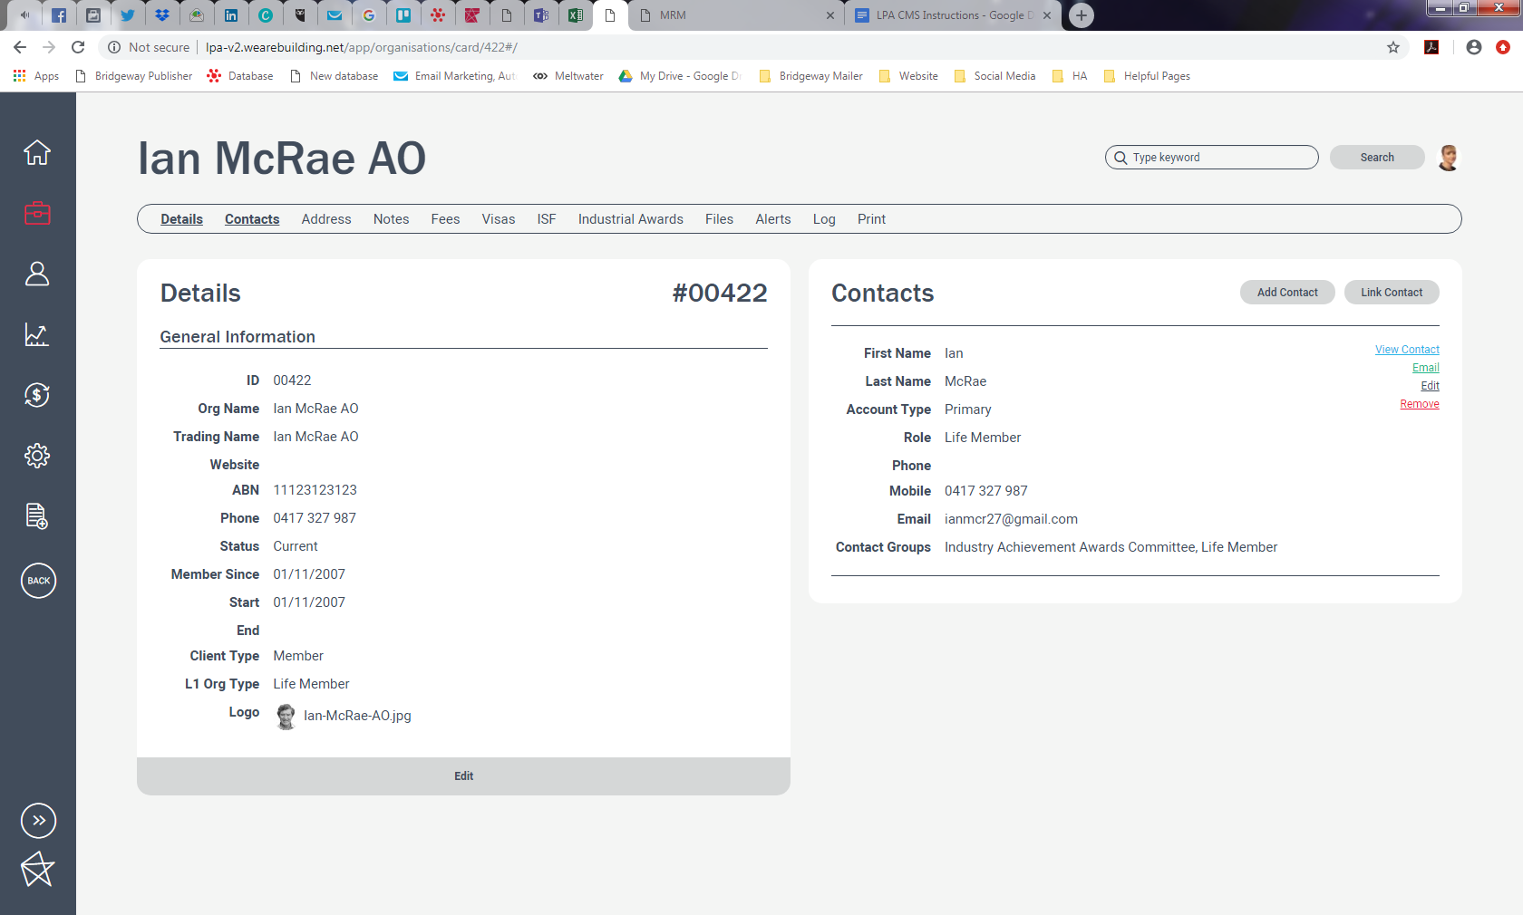Click on ‘edit’ to make changes to the person’s details. Here you will also be able to upload their headshot which is listed here as ‘logo’.

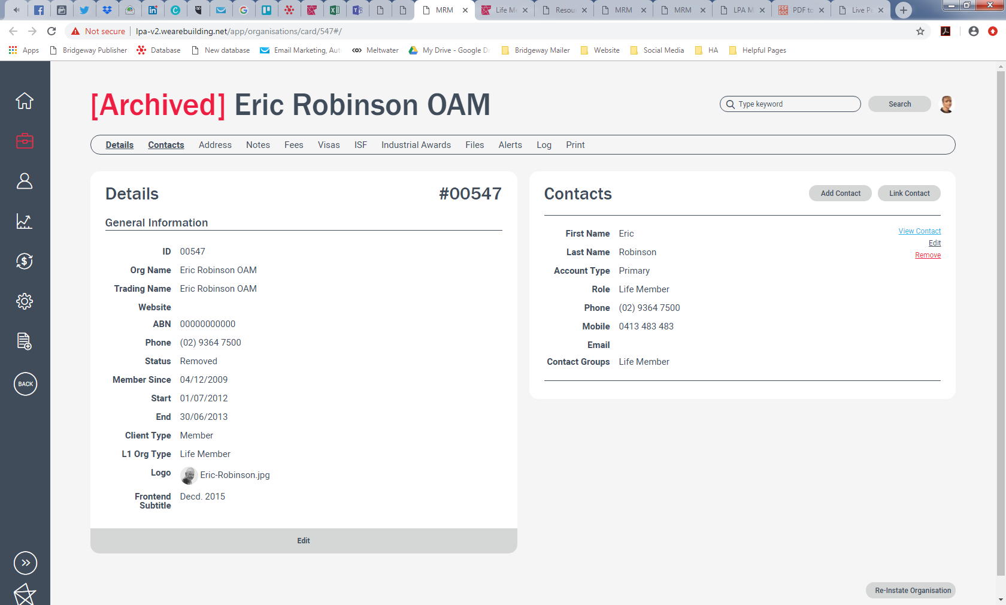

For Life Members who have died, use this section to free type: Decd.Year. You need to have their year of death.

For new Life Members please see the Finance & Membership Manager so they can create this organisation card for you and then follow the steps listed above.

Questions?

Any questions please contact:

Sarah Pudelko

LPA Marketing Coordinator

[spudelko@liveperformance.com.au](mailto:spudelko@liveperformance.com.au)

Alice Moir

Paoli Smith UX/Digital Designer

[alice@paolismith.com.au](mailto:alice@paolismith.com.au)

(03) 9419 2447

9419 2447