[DATE]

**Ms Evelyn Richardson**

Chief Executive

Live Performance Australia

Level 1, 15­–17 Queen Street

MELBOURNE

VIC 3000

TEMPORARY ACTIVITY VISA/S (SUBCLASS 408) ENTERTAINMENT ACTIVITIES APPLICATION/S

[NAME OF TOUR/PRODUCTION/EVENT]

Dear Ms Richardson,

This letter is to confirm that the Australian Entertainment Industry Association (AEIA), trading as Live Performance Australia (LPA) is authorised to act on our behalf in lodging the Temporary Activity visa/s (subclass 408) Entertainment activities application/s and associated matters, in respect of the above tour/production/event.

I confirm that Australian Award minimum wages and conditions are being met for the above tour/production/event.

Yours sincerely,

[Name]

[Position/Title]

[Organisation]

**Visa Application Charges Authorisation**

The Department of Home Affairs requires that all forms/documentation for a particular tour or group are lodged together. Therefore, LPA will lodge visa applications for tours/groups and process payment at the one time. The exception is applications for additional or replacement visa Applicants, which LPA will lodge separately from the main group/tour.

Please complete the below credit card authorisation form to authorise LPA to charge your credit card to process the visa application charge/s.

I,_____________________________ (print name), authorise the Australian Entertainment Industry Association trading as Live Performance Australia, to charge the below credit card to process the visa application charge/s on behalf of _______________________ (print proposer/sponsor name):

[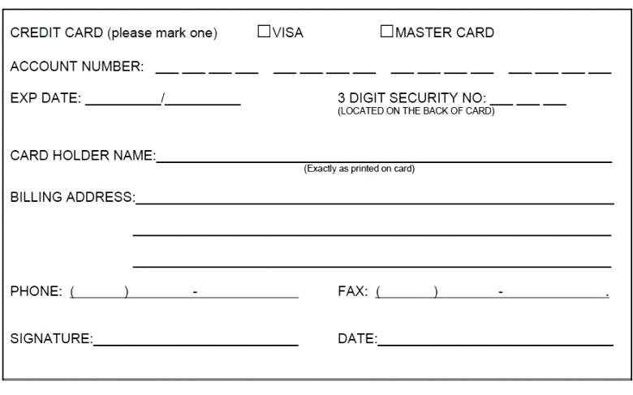](http://www.google.com/url?sa=i&rct=j&q=&esrc=s&source=images&cd=&cad=rja&uact=8&ved=2ahUKEwjA5PDW34fgAhUbSI8KHSuIAvgQjRx6BAgBEAU&url=http%3A%2F%2Fwww.google.com%2Furl%3Fsa%3Di%26rct%3Dj%26q%3D%26esrc%3Ds%26source%3Dimages%26cd%3D%26ved%3D2ahUKEwjvyuHS34fgAhUN3Y8KHfSHBGIQjRx6BAgBEAU%26url%3Dhttp%253A%252F%252Ftexasvetcancerregistry.com%252Fcredit-card-payment-form-template%252F%26psig%3DAOvVaw06D1DH0Mh5wCamO5DcnPlH%26ust%3D1548464916091567&psig=AOvVaw06D1DH0Mh5wCamO5DcnPlH&ust=1548464916091567)

**Visa Application Charge (VAC) as of 1 July 2019.\***

|  |  |
| --- | --- |
| **Applications** | **Rate** |
| 408 visa applications | $310 per person (Inc. GST) |

*VAC concessions apply for Charities and Not for profit organisations. Please contact LPA for further information.