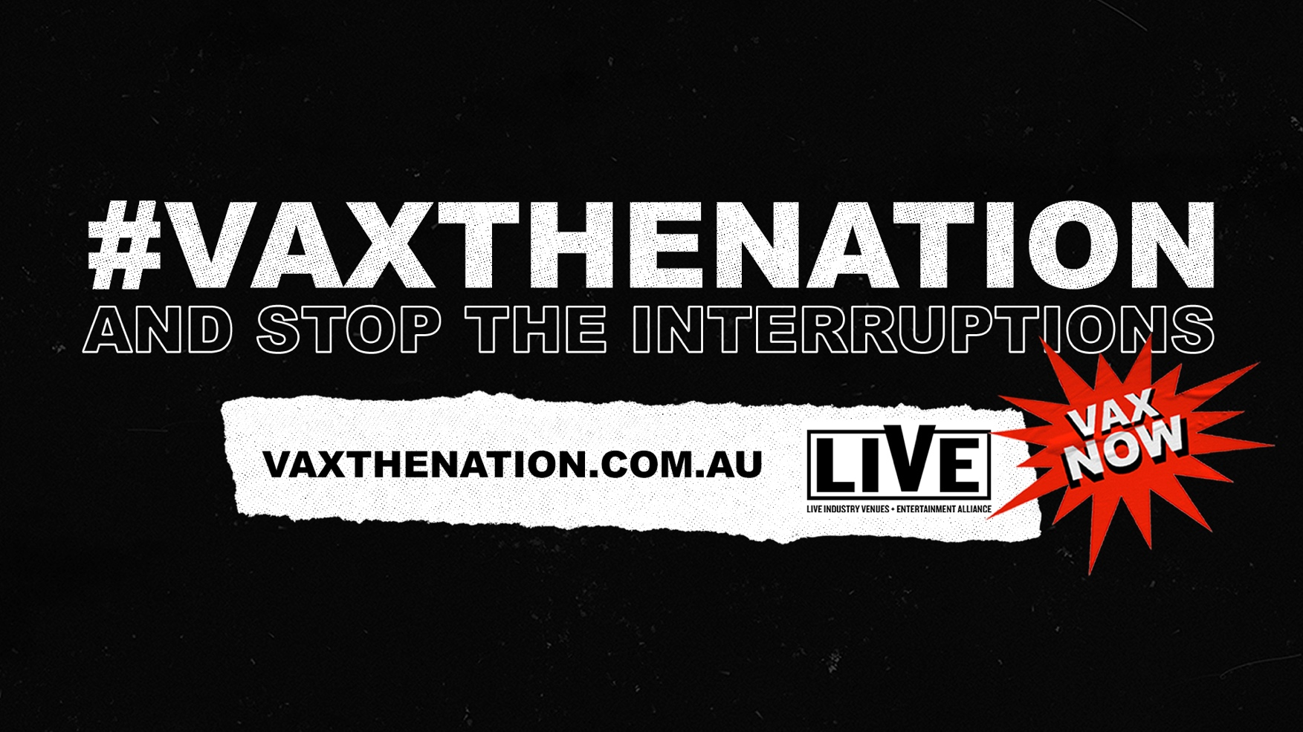

**Thank you so much for supporting the #vaxthenation campaign. With our voices united we can make a difference.**

**#VAXTHENATION and stop the interruptions**

**STRICT EMBARGO TIMES ARE OUTLINED IN THE DOCUMENT BELOW**

_________________________________________________________________________

*We acknowledge the Traditional Custodians of all across the continent. And pay our respects to their elders - past and present. We honour the important role music has played and continues to play on these lands for thousands of years.*

**GET SOCIAL WITH #VAXTHENATION!**

We encourage you and your teams to please follow and tag the #vaxthenation campaign pages as much as possible. We will be sharing artist and business content to this page across the campaign period.

(note: some accounts won’t be live until Monday’s launch)

**YouTube** [**https://www.youtube.com/vaxthenationau**](https://www.youtube.com/vaxthenationau)

**Facebook** [**https://www.facebook.com/vaxthenationau**](https://www.facebook.com/vaxthenationau)

**Instagram**  [**https://www.instagram.com/vaxthenationau**](https://www.instagram.com/vaxthenationau)

**Twitter** [**https://twitter.com/vaxthenationau**](https://twitter.com/vaxthenationau)

**Tiktok** [**https://www.tiktok.com/@vaxthenationau**](https://www.tiktok.com/@vaxthenationau)

**Contact for #vaxthenation socials**

Day to day and organic content: Emily Bass [emily.bass@mushroomgroup.com](mailto:emily.bass@mushroomgroup.com)

Feel free to re-share any content.

Paid/boosted: Paige X. Cho [paige@blstr.co](mailto:paige@blstr.co). **Please contact Paige to set up *Advertiser Access* and if you are ok giving us access to target your fans with VTN content.**

_________________________________________________________________________

**READ THE LAUNCH PRESSER**

Read the press release [here.](https://mushroomgroup365.sharepoint.com/:f:/s/vaxthenation/El_5f61lmklKuJgN4Pn4CNQBQtmLUW71HoYk176tyL0oHA?e=7RDQ8q)

_________________________________________________________________________

**OTHER IMPORTANT LINKS**

[Campaign overview](https://lne.box.com/s/2c203byjrxoiggoay6dwewnwssp357c6).

Box folder of [all assets](https://lne.box.com/s/yokfw41likih0jjcdvmaxg0eu8d1fmzq) (direct links below)

TV SPOT

**Hero**

Facebook – <https://www.facebook.com/watch/?v=528428321786815>

YouTube - <https://youtu.be/Kg3Nup7SljA>

**First Nations**

Facebook - <https://www.facebook.com/watch/?v=440394217224254>

YouTube - <https://youtu.be/9xV1Sh4PaNQ>

**Theatre**

Facebook - <https://www.facebook.com/watch/?v=2949377922042970>

YouTube - <https://youtu.be/BZ7p2fuoiJg>

Comedy

YouTube: <https://youtu.be/k4H6XlD3IVI>

Facebook: <https://www.facebook.com/watch/?v=437561614284000>

LGBTQI

YouTube: <https://youtu.be/p0QnjggWj30>

Facebook: <https://www.facebook.com/watch/?v=536294270982090>

Boomer

YouTube: <https://youtu.be/-xH6Tl6NJAU>

If you have any issues with accessing or questions on the assets, please contact Michelle Lucia [michelle.lucia@livenation.com.au](mailto:michelle.lucia@livenation.com.au)

**GET ASSET READY**

[Click HERE for the full #vaxthenation asset cheat sheet](https://lne.box.com/s/0h431c1dqk1i63fgar95yppjrm6crwx0)

If you have any issues with accessing or questions on the assets, please contact Michelle Lucia [michelle.lucia@livenation.com.au](mailto:michelle.lucia@livenation.com.au)

**Please note the strict embargo times in the grid below!**

|  |  |  |  |  |
| --- | --- | --- | --- | --- |
| **DATE** | **STAGE** | **WHAT** | **KEY COPY TO INCLUDE** | **ASSETS AVAILABLE** |
| NOW | Get ready for launch | You have the option to customise your own #vaxthenation assets | See options below. | [Glitch End Board Template](https://lne.box.com/s/q7vepu58pur84ncn6l1u0004xzcu3enl) – add your own footage to the video interruption template  View an applied example [HERE](https://app.box.com/file/854138660380?s=8705i5lhiu2eo5d01fx8pbwfyfgvi7oy)  [Poster Interruption](https://app.box.com/folder/144765228361?s=gn8hl4h41s7sjkfjf9bdeizsam6aobgu) – use your own poster and add the interruption rip |
| Sunday 5 September  6pm AEST | Interruptions Tease | Interrupt social media and replace your profile image and header image with the interruption asset  OR simply post to your wall/stories | **Stop The Interruptions**  *NOTE: pls don’t reference the hashtag or anything else* | [Still images](https://lne.box.com/s/ipimp5nlvkwc144hx5x43kkfv8l6un5g), options for profiles/cover  [Video](https://lne.box.com/s/utdutavpnkocnxswy69l54rkljf0ekjc) |
| Monday 6 September 6am AEST | #vaxthenation launch | Post the main video asset as a first preference  OR  Post your own customised content (per above)  OR  Use the Poster or Generic Assets | **Example FB copy for businesses/organisations (profile name is Stop The Interruptions)**   * Australia, it's been a tough year and a half. <ORG NAME> is supporting the #VaxTheNation movement to @StopTheInterruptions and go back to the life we enjoy. More info: [vaxthenation.com.au](https://hes32-ctp.trendmicro.com:443/wis/clicktime/v1/query?url=http%3a%2f%2fvaxthenation.com.au&umid=a91ec2bd-ddde-4212-b56e-9ab1999b0654&auth=efca101ca3895ebe17fb35e375fe1f9b24400477-68463a01b33ae984088fbc8b867fc7f117453c79) * Australia, we have grand plans for you with <UPCOMING SHOWS>. Get the jab now to @StopTheInterruptions so we can go back to life as you know it. More info: [vaxthenation.com.au](https://hes32-ctp.trendmicro.com:443/wis/clicktime/v1/query?url=http%3a%2f%2fvaxthenation.com.au&umid=a91ec2bd-ddde-4212-b56e-9ab1999b0654&auth=efca101ca3895ebe17fb35e375fe1f9b24400477-68463a01b33ae984088fbc8b867fc7f117453c79) * <ORG NAME> is supporting the #VaxTheNation movement. We're going to get the jab now to @StopTheInterruptions. More info: [vaxthenation.com.au](https://hes32-ctp.trendmicro.com:443/wis/clicktime/v1/query?url=http%3a%2f%2fvaxthenation.com.au&umid=a91ec2bd-ddde-4212-b56e-9ab1999b0654&auth=efca101ca3895ebe17fb35e375fe1f9b24400477-68463a01b33ae984088fbc8b867fc7f117453c79) * Australia, it's time to get the show back on the road. <ORG NAME> is supporting the #VaxTheNation movement. More info: [vaxthenation.com.au](https://hes32-ctp.trendmicro.com:443/wis/clicktime/v1/query?url=http%3a%2f%2fvaxthenation.com.au&umid=a91ec2bd-ddde-4212-b56e-9ab1999b0654&auth=efca101ca3895ebe17fb35e375fe1f9b24400477-68463a01b33ae984088fbc8b867fc7f117453c79) * We cannot wait for life after lockdowns. Join us and the wider <MUSIC/LIVE ENTERTAINMENT/COMEDY/THEATRE/DANCE/OPERA> industry and get vaccinated to @StopTheInterruptions. #VaxTheNation [vaxthenation.com.au](https://hes32-ctp.trendmicro.com:443/wis/clicktime/v1/query?url=http%3a%2f%2fvaxthenation.com.au&umid=a91ec2bd-ddde-4212-b56e-9ab1999b0654&auth=efca101ca3895ebe17fb35e375fe1f9b24400477-68463a01b33ae984088fbc8b867fc7f117453c79)   **Example IG copy for businesses/organisations:**   * Australia, it's been a tough year and a half. It's been too long since we've been able to put on <FESTIVAL/SHOW/EVENT>, and it's time to stop the interruptions and get the jab. #VaxTheNation @VaxTheNationAU for more info. * There's no time like the present to get the 💉 and stop the interruptions! <ORG NAME> is supporting #VaxTheNation. @VaxTheNationAU for more info. * We cannot wait for life after lockdowns. Join us and the wider <MUSIC/LIVE ENTERTAINMENT/COMEDY/THEATRE/DANCE/OPERA> industry and get vaccinated! #VaxTheNation @VaxTheNationAU for more info. * We can't wait to get the show back on the road for you. Here at <ORG NAME> we're supporting #VaxTheNation to stop the interruptions. @VaxTheNationAU for more info. | **HERO VIDEO**  TV advert (on [YouTube](https://www.youtube.com/watch?v=5D0oFqIa7S4))  **INTERRUPTED POSTER CAMPAIGN ASSETS**   * [Poster (Still) campaign assets](https://app.box.com/folder/144765171870?s=x6t31pfrl477mtl349reay94vh6g5mim) * [Poster (Gif/Video) campaign assets](https://app.box.com/folder/144765171870?s=x6t31pfrl477mtl349reay94vh6g5mim)   **GENERIC #VAXTHENATION ASSETS**   * [Generic Assets](https://lne.box.com/s/fw1bul3gonywsrmkpbjn1ttbixyevbuj) |
| Monday 6 September onwards | #vaxthenation launch | Email your database | *Australia, now is our moment.*  *It’s time to get out there and soak up all the entertainment we’ve been missing.*    *That incredible feeling of singing along to your favourite band in a crowd of thousands, arms around your mates under an open sky. Hearing an entire audience laugh alongside you at a sold-out comedy show. Feeling the passion at your local theatre, or getting lost in the beauty of a classical symphony performance.*    *We’ve missed them. They’ve missed us.*    *Let’s roll up our sleeves, get vaxxed and bring them back.*    *You can help stop the interruptions, vax now to #vaxthenation!* | [Email tiles](https://lne.box.com/s/fl0kos9irmv2iiactmpg2olag63j1e7o) for inclusion or solus |
| Monday 6 September onwards | #vaxthenation launch | Display banners for your websites. . If you need any alternate sizes, please reach out to [michelle.lucia@livenation.com.au](mailto:michelle.lucia@livenation.com.au). |  | Display [banner sizes](https://lne.box.com/s/vp0ug5gepol304bxthz044lec4jzskdx) |
| Monday 20 September onwards | Secondary campaign | Details to come |  |  |

_________________________________________________________________________

**Talking Points**

**WHAT** - **#VAXTHENATION** is a campaign asking Australians to help ‘stop the interruptions’ and get vaccinated! **#VAXTHENATION** has brought our Music & Entertainment Industry together as never before, with more than 300 Artists + Organisations teaming up.

**WHO** – The Campaign is spearheaded by the ‘**LIVE Alliance’ (Live Industry Venues + Entertainment):** a group of 10 major players – the Association of Artist Managers (AAM), APRA AMCOS, Australian Recording Industry Association (ARIA), Australian Festivals Association (AFA), Frontier Touring/Mushroom Group, the Live Entertainment Industry Forum, Live Nation, Live Performance Australia (LPA), Secret Sounds and TEG.

The Alliance has enlisted Artists, promoters, festivals, venues, ticketing agencies, record labels, comedy producers, theatre, dance and opera companies, streaming platforms, peak industry bodies and more to join in the campaign.

**WHEN** – It launches on Monday 6th September with a TV commercial & will continue until we reach the 80% vaccination target set by National Cabinet.

**WHY** – Dealt a massive blow over the past 18 months, our Live Events sector has seen thousands of performances disrupted, postponed or cancelled, tens of thousands of workers stood down (or unable to work at all), and hundreds of millions of dollars lost. In addition, the lack of flow-on revenue from these missing shows hugely effects hospitality, accommodation and tourism industries too.

**OUR MESSAGE** – We want ALL Aussies to remember the good times Live Events bring! Unless we reach the 80% target, there will be no live music; no festivals; no theatre; no opera; no dance; no comedy; from local or international act… The best way you can help us to ‘stop the interruptions’ is to get vaxxed as soon as you can! Let’s get our Industry back on the road.

**TIPS FOR MEDIA INTERVIEWS** –

* **#VAXTHENATION** covers the whole Live Entertainment sector (i.e. music, comedy, theatre, ballet, opera etc)
* If talking about hardships our Music Industry has faced, remember to keep it relatable. The campaign message is not ‘Save the Music Industry’ – it’s ‘Get vaccinated!’
* The campaign is not political or aligned with Government.
* #VAXTHENATION is funded by the Campaign Partners
* Talk up the positives of what can be gained if we get our jabs: live events, seeing our families & friends, restrictions being lifted… paint a picture of how 2022 might look
* Try not to get too political: the public is tired of politicians
* *“Should there be a vaccine passport for gigs?”* – that’s not what this campaign is about. Until we reach 80% targets, there won’t be any shows to need a ‘passport’ for!
* “*Anti-vaxxers*”: try not to rise to their bait – media want a headline. Be measured in your response if you can!

**CALL TO ACTION** – Vax now so you can help #vaxthenation to stop the interruptions. Head to the **#VAXTHENATION** website for further details: [vaxthenation.com.au](http://www.vaxthenation.com.au).

